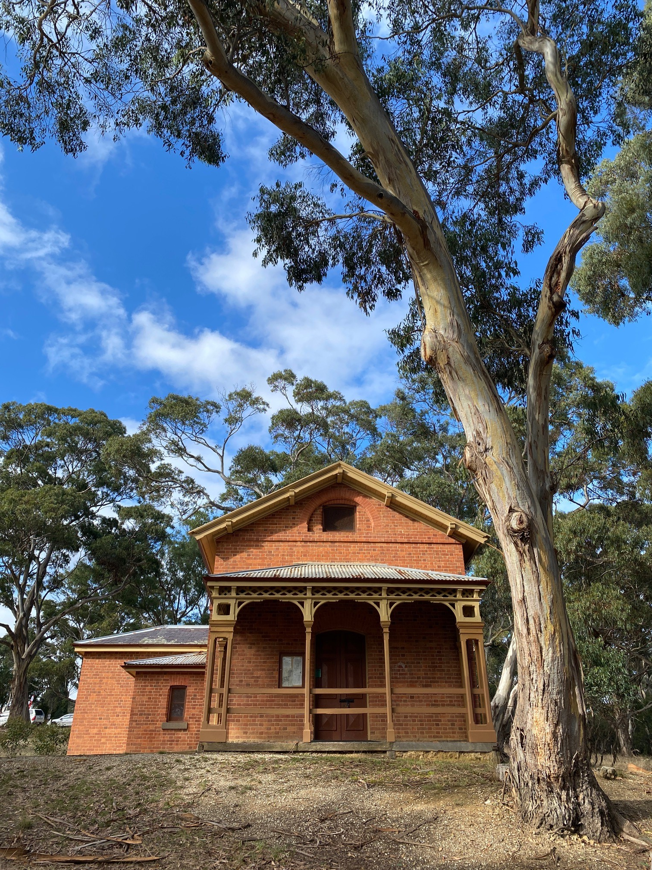
Steiglitz Historic Park
Education Program
Ranger-led activities

Program logistics
 | Cost | $8.50 per student. Supervising teachers attend for free. An invoice will be sent via email after your visit to the park.
 | Location | Steiglitz Historic Park  The Court House - Meredith-Steiglitz Rd, Steiglitz VIC 3331
 | Year levels | Year 3 – Year 12
 | Learning areas | History  Geography  VCE Outdoor and Environmental Studies
 | Accessibility | Please inform education staff at the time of booking if students have specific access or other requirements.
 | Contact | To book or discuss your school needs, please email: SerendipEducationCentre@parks.vic.gov.au  or contact the Education Officer on 8427 3486

Additional resources to support
your learning
Visit http://www.parks.vic.gov.au/get-into-nature/learning-in-nature/plan-your-learning

On the day
- Ensure students bring sunscreen, a drink bottle and pens/clipboard.
- Students must wear suitable clothing and sturdy covered footwear (no thongs or crocs).
- Local weather may vary from regional forecasts. Check the local weather and dress accordingly.
- The healthiest food for wild animals occurs in nature – do not feed or encourage animals to take any human food.
- Leave as little trace of your visit as possible – take all rubbish out of the park and keep to existing tracks.
- Plants, animals and other natural features, objects, and cultural sites in the park are protected by law and must not be disturbed or removed.

About the park
Steiglitz Historic Park
Little more than an hour's drive from Melbourne and set in the Brisbane Ranges National Park, Steiglitz Historic Park is a window back in time to Victoria's Gold Rush of 1850-90s.
Situated between Geelong and Ballarat, Steiglitz is almost a ghost town today, but from 1860 to 1890 it was a busy goldmining township with hotels, shops and churches. At the height of the 1860s gold rush, Steiglitz township had more than 2000 residents, four hotels, a newspaper, a variety of shops and even an undertaker!
Now most of the town and its surroundings are included in the Steiglitz Historic Park.
Curriculum-aligned education sessions at Steiglitz offer students an excellent opportunity to learn about the history of the park and the impact of the gold rush.

Primary school programs

Gold Rush Discovery
 | Levels  3-4 | Students can re-imagine what life was like in a gold rush town in the 1850s. They learn how the discovery of gold in Steiglitz changed the landscape and how park rangers look after the historic park. The students learn about the history of Steiglitz and how different groups have connected with and used the town over time.  Learning outcomes:  VCHHC068, VCHHC070, VCHHK073, VCGGC071, VCGGC073, VCGGK083  Links to UN Sustainable Development Goals:
Learning area
History, Geography
Location
The Court House, Steiglitz Historic Park
Time
60 minutes

Gold Rush Connections
 | Levels  5-6 | Students can re-imagine what life was like in a gold rush town in the 1850s. They learn about how the gold rush influenced change in the Australian colonies and in Australian society. The students learn how the gold rush changed the environmental characteristics of Steiglitz and how park rangers look after the historic park today.  Learning outcomes:  VCHHC084, VCHHC086, VCHHK089, VCGGC085, VCGGC087, VCGGK094, VCGGK096  Links to UN Sustainable Development Goals:
Learning area
History, Geography
Location
The Court House, Steiglitz Historic Park
Time
60 minutes

Secondary school programs

Changes in the Landscape at Steiglitz
 | Levels  7-8 | Students can re-imagine what life was like in a gold rush town in the 1850s. They learn about the history of Steiglitz and how the landscape around Steiglitz has changed over time. The students learn about the impacts of the gold rush to the natural environment and how park rangers protect the historic park today.  Learning outcomes:  VCHHC100, VCHHC103, VCGGK119  Links to UN Sustainable Development Goals:
Learning area
History, Geography
Location
The Court House, Steiglitz Historic Park
Time
60 minutes

Perceptions and Management at Steiglitz
 | Levels  9-10 | Students can re-imagine what life was like in a gold rush town in the 1850s. They investigate how economic factors changed the environment around Steiglitz and how park rangers manage the historic park and surrounding National Park. Students also learn about different people’s perception of the park, and how these perceptions influence their connections to place.  Learning outcomes:  VCHHC124, VCGGK139, VCGGK144, VCGGK145, VCGGK147  Links to UN Sustainable Development Goals:
Learning area
History, Geography
Location
The Court House, Steiglitz Historic Park
Time
60 minutes

Steiglitz through Time
 | Levels  VCE Outdoor and Environmental Studies  VCE History | Students can re-imagine what life was like in a gold rush town in the 1850s. They learn about connections that different people have had with the area around Steiglitz through time, including how natural resource access has influenced the uses of this landscape. Students also learn about how park rangers and the Steiglitz community care for the historic park.  Links to UN Sustainable Development Goals:
Learning area
OES: Unit 2 (AOS2) and Unit 3 (AOS1)
History: Unit 3 and 4 (AOS1)
Location
The Court House, Steiglitz Historic Park
Time
60 minutes

