Wilsons Promontory National Park
Education Program 2022

Prom Sanctuary – a safe haven in a changing climate
Wilsons Promontory National Park is becoming a safe haven for native plants and animals to thrive in Victoria's largest conservation sanctuary. Exciting new ranger-led activities are being developed to explore the key themes of the Prom Sanctuary concept. Experience authentic place-based learning opportunities that offer insight into this extraordinary undertaking.
For information on what is happening at the Prom we encourage you to subscribe to the Wilsons Prom Community Newsletter here

Ranger-led activities
Theme: Connecting people and nature

NEW/FREE Welcome to the Prom
Levels: 3-Tertiary
Location: Starts from Lilly Pilly Gully Car Park
Time: 60 minutes

The arrival experience at the Prom is enhanced by a welcoming ranger-led short 1km walk along the Lilly Pilly Link Track to Tidal River. Take this enlivening perspective to awaken spatial connectivity and prompt ecological awareness of the Prom.

PRIMARY Tracks and Traces
Levels: 3-6
Key learning area: Science, geography
Location: Tidal River campground or Wildlife Walk (Yanakie Isthmus)
Time: 60 minutes
Moving into their surrounds, students observe signs of ‘unseen’ live animal presence by discovering tracks and traces. These skills inform readability and connections with the local environment. The session culminates with student-led ecological representation and storytelling on a canvas of sand.

PRIMARY Living on the Edge (low tide only)
Levels: 3-6
Key learning areas: Science, Geography
Location: Picnic Bay or Whisky Bay
Time: 60 minutes

Exploring the intertidal and beach zone, students become familiar with Victoria’s unique southern waters. They discover and identify a variety of species and observe unique features. Students consider environmental factors and the difficult conditions that impact growth and survival of plants and animals in this zone. The tidal influence encourages exploration of the beach wash and unusual beachcombed objects.

NEW PRIMARY/SECONDARY When reputations stick
Levels: 3-8
Key learning area: Science, Geography
Location: Tidal River campground
Time: 60 minutes

The wombats of Tidal River campground have a long-standing reputation as ‘Tent Raiders’ amongst Prom campers. On a short walk through the camping area, students look for and map signs of animal presence before they come across a ‘Tent Raider’ crime scene. A forensic investigation ensues addressing the question ‘who is responsible for this?’. This delivers connection to the problematic aspects of shared human and wildlife relationships in Tidal River.

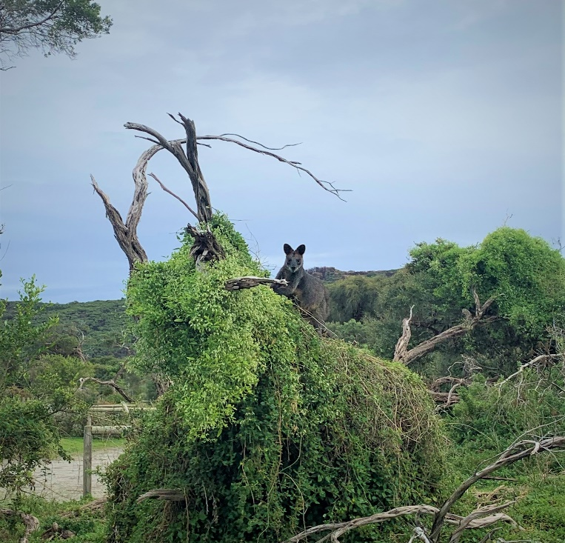

Theme: Caring for country

Love the Prom! SECONDARY/TERTIARY
Levels: 7-Tertiary
Key learning areas: Science, Geography
Location: Various
Time: 60 minutes

These FREE nature conservation management activities offer students the opportunity to contribute to the health of the Prom environment.
Revegetation (Winter/Spring)
Students engage in tree planting and maintenance tasks. When possible, the Friends of the Prom (Volunteer Group) are involved in this activity.
Marine debris (All Year)
Students gain awareness and insight into the impacts of waste on marine and coastal life.
Habitat care and management (All Year)
Students identify the presence of an invasive coastal plant and recognise how it influences ecological imbalance on the Prom’s coastline
NEW Citizen science (All Year)
Help scientists understand how changes in our climate impact the flora and fauna at Wilsons Prom. A great opportunity to become a citizen scientist and collect valuable scientific data along the 900m Lilly Pilly link track.

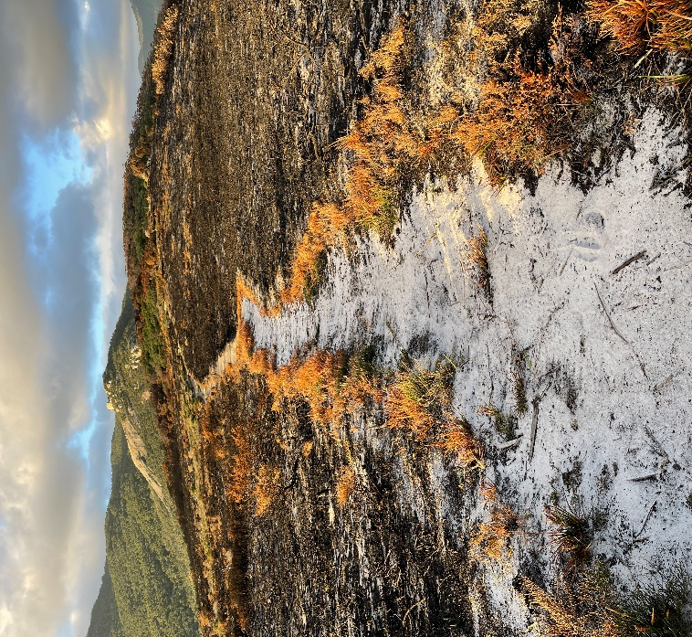

NEW SECONDARY Fire in the Landscape
Levels: 7-10
Key learning area: Science, geography
Location: Tidal Overlook Track
Time: 60 minutes
Students become familiar with past and present fire relationships at the Prom. On a short walk, through a nearby planned burn area, plant fire adaptations and animal responses to fire are explored. Students compare burnt and unburnt landscapes through vegetation monitoring tasks.

Theme: Conservation Careers
SECONDARY On the Job
Levels: VCAL
Strand: Work-related skills
Location: Tidal River
Time: 60 minutes

This practical activity is tailored to provide students with an insight into the workplace operations of Parks Victoria staff in Wilsons Promontory National Park. They will gain career pathway knowledge and an understanding of the skills required to work in a large park management setting. In 2023 this activity will be further aligned to the VCE Vocational Major.

VCE Curriculum-aligned activities

Past Uses of the Prom
Subject: VCE Outdoor and Environmental Studies
Unit 3 AOS1
Key knowledge areas: Increasing population, Industrialisation and Nation Building.
Location: Wildlife Walk (Yanakie Isthmus) or Darby River
Time: 90 minutes

The Prom has a varied history of land use from the earliest indigenous inhabitants to present day visitors. A comprehensive VCE unit of study resource supports teachers and students to explore the key knowledge points of Unit 3 AOS1 in relation to seven locations throughout the national park. Two VCE aligned
Ranger-led sessions engage students in ‘Industrialisation and Nation building’ (Darby River) and ‘Increasing populations’ (Wildlife Walk, Yanakie Isthmus).

Healthy Outdoor Environments
Subject: VCE Outdoor and Environmental Studies
Unit 4 AOS1
Key knowledge area: Observable characteristics of healthy outdoor environments.
Location: Norman Bay
Time: 90 minutes
Students gain an insight into Parks Victoria’s conservation strategies for healthy and sustainable environments at the Prom. Students use scientific monitoring methods to assess the health of a coastal habitat and examine the conditions, threats and strategies.
NEW VCE Activities in 2023 (Bookings open)

Prom Sanctuary – Restorative Ecology
Subject: VCE Environmental Science
Unit 1 AOS2, AOS3
Location: Northern Prom (varied locations)
Time: 1 or 2 day program
Special note: This activity requires planning time, please book 4 to 6 weeks in advance.

This activity explores the key themes of the Prom Sanctuary concept and facilitates curriculum aligned authentic place-based learning opportunities with staff sharing their work and strategy behind creating a safe haven for the future. Students are guided by an overarching inquiry-based question concerning ecological imbalance. ‘Is a fenced response critical to the ecological restoration of the Yanakie Isthmus coastal grassy woodland?’ Students partake in a range of investigative methodologies, for example, wildlife camera monitoring, vegetations transects and habitat assessments.

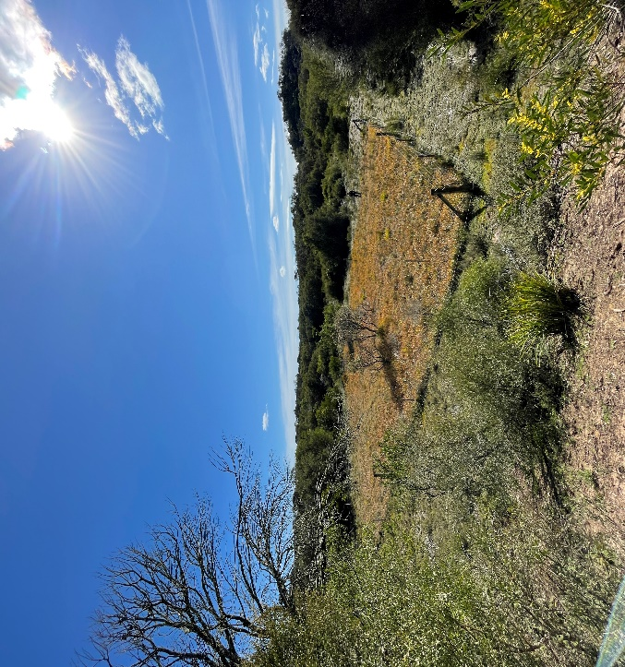

Investigating outdoor environments
Subject: VCE Outdoor and Environmental Studies
Unit 2 AOS1
Key knowledge area: Scientific understanding of specific outdoor environments.
Location: Northern Prom (varied locations) or Tidal Overlook
Time: 100 minutes

Through storytelling students become familiar with past and present fire relationships at the Prom. The notion of a ‘planned burn’ is explored from perspectives of purpose, planning and logistics. A visit to a burnt area initiates observation and recording of plant adaptations and animal responses to fire. Related practical fire assessment techniques, such as assessing fuel loads or investigating leaf litter moisture levels are demonstrated.

Human induced impacts on outdoor environments
Subject: VCE Outdoor and Environmental Studies
Unit 2 AOS2
Key knowledge area: The impact of conservation activities on outdoor environments.
Location: Northern Prom (varied locations)
Time: Variable (in accordance with group needs)

The student view of this Prom Sanctuary inquiry is deepened in special locations, through stories of the past and enlivening
spatial connection to the northern Prom. The background and conservation tasks involved with creating a fenced sanctuary become transparent.

Self-guided activities
A range of pre-visit and in-situ self-guided resources are available including:
- Whale Watch (Winter/Early spring)
- ClimateWatch Trail
- Marine Debris

Tertiary Groups
Contact us to customise a Ranger-led engagement specific to your focus.

Digital Nature Education resources
Ask us about the range of pre- and post-visit classroom resources available to complement your in-park experience.

Planning your excursion
To book and to discuss your school needs, please email wpromeducation@parks.vic.gov.au or contact the Wilsons Promontory education team on 03 8427 2122.

Costs
The current cost for a Ranger-led activity is $6.50 per student, with a minimum charge of $65 per session. Supervising teachers attend for free. An invoice will be sent via email after your visit to the park. Welcome to the Prom and the Love the Prom! activities are free.

Teacher/Student Ratios
School staff participate in the sessions provided and are expected to supervise and manage student behaviour. Parks Victoria recommends the following education group staff-to-student ratios:
- 1:1 for specific needs
- 1:5 for Levels Prep – 2
- 1:10 for Levels 3 – 12
- 1:20 for Tertiary

Accessibility & inclusion
Please inform education staff at the time of booking if students have specific access or other requirements.
Outdoor components of activities may take place on unsealed tracks with uneven surfaces. All-terrain TrailRider wheelchairs and beach wheelchairs are available for use by students with restricted mobility (free of charge, advance bookings essential). TrailRiders and beach wheelchairs can be used on surfaces that are not accessible using conventional wheelchairs. School staff are responsible for the safe transfer of the user.

A social script is available for participants on the autism spectrum. Using plain text and images, the social script describes what children may see and experience during their visit to the Prom. View this resource here - https://www.parks.vic.gov.au/get-into-nature/all-abilities-access/autism-friendly-visits
On the day
- Ensure students bring sunhat, sunscreen, a drink bottle and pens/clipboard.
- Local weather may vary from regional forecasts. Check the local weather and dress accordingly. Students must wear suitable outdoor clothing and sturdy fully-covered footwear.
- All educations sessions will run in strict accordance with current DHHS guidelines.

