Williamstown Local Port Area Plan
December 2023

Acknowledgement of Country
We acknowledge the Bunurong people, who have been the custodians of this land and sea country for many thousands of years; and pay respect to their elders past and present. We acknowledge that the land of which we speak is the place of age-old ceremonies, celebrations, initiation and renewal; and that the Bunurong peoples’ living culture continues to have a unique role in the life of this region.
This publication may be of assistance to you but Parks Victoria and its employees do not guarantee that the publication is without flaw of any kind or is wholly appropriate for your particular purposes and therefore disclaims all liability for any error, loss or other consequence which may arise from you relying on any information in this publication.
Authorised and published by Parks Victoria
Level 10, 535 Bourke St, Melbourne
Cover image: Williamstown Local Port Area and proximity to Melbourne CBD

Contents
1 Executive summary 4
2 Introduction 5
2.1 Purpose 5
2.2 Site Context 6
2.3 Stakeholder engagement 7
3 Strategic context 8
3.1 The Williamstown Maritime Precinct Framework and relevance to the Local Port Area Plan 8
4 Proposing a thriving future for the Williamstown local port area 9
5 Improving the function of the local port area 10
6 Proposing a future for the piers and jetties 11
6.1 Workshops Pier 11
6.2 Commissioners Jetty 11
6.3 Boyd Street Pier 11
6.4 Gem Pier 12
6.5 Ferguson Street Pier 12
7 Strategic directions (on-water functions and placemaking) 13
7.1 Bunurong aspirations for Sea Country 13
7.2 Maritime and European heritage 13
7.3 Foreshore connectivity 13
7.4 Dredging and fairways 14
7.5 Environmental resilience 14
7.6 Wave climate 15
8 Next Steps and Implementation 16
References 17

Executive summary
The Williamstown Local Port Area (LPA) is a premier maritime destination on Bunurong Sea Country. With a proud and vibrant history as one of Victoria’s focal maritime hubs, it has long been home to a wide range of recreational, community and commercial berthing activities. Boasting scenic views towards Melbourne’s CBD, the area supports a significant volume of maritime traffic and fosters connections to Victoria’s maritime history through the Seaworks Maritime Museum and HMAS Castlemaine. Williamstown is the only remaining small commercial berthing facility in the inner CBD given the closures of Maribyrnong, Princes Pier and Docklands to these vessels.
As the local port manager for Port Phillip which includes a large portion of Hobsons Bay at Williamstown, Parks Victoria has been funded by the Department of Transport and Planning (DTP) to deliver the Williamstown Local Port Area Plan (LPAP). Local Port Area Plans are delivered under the Sustainable Local Ports Framework and inform the prioritisation of asset investment based on the broader local port precinct. This will more effectively achieve better economic, environmental and community outcomes.
The Williamstown LPAP (Plan) is a continuation of the broader Williamstown Maritime Precinct Framework. It seeks to realise the inherent opportunities in celebrating the local port area as a living maritime heritage destination, while responding to existing and future demands for commercial and recreational on-water uses. By investing in the Williamstown Local Port Area, it will support water-based amenity, events and economic activity for Melbourne’s west, delivering more efficient maritime industry and operations.
Through technical investigations and studies, along with stakeholder and community engagement, a clear vision for the on-water assets and their function has been identified. This plan responds to identified aspirations and challenges and provides place-based key actions and proposals to enhance the Williamstown local port area.
This plan addresses the future of five piers and jetties and identifies key actions to support their function. These assets are Workshops Pier, Boyd Street Pier, Commissioners Jetty, Gem Pier and Ferguson Street Pier. The plan proposes Boyd Street Pier will provide for commercial and emergency response services. Workshops Pier will remain a key facility that enables Seaworks to develop and become the home of dynamic and living maritime heritage events. The removal of Commissioners Jetty will provide opportunity for surrounding piers to service the LPA needs.
The plan also identifies key strategic directions and actions to support the piers and jetties. These actions include dredging, capturing the Bunurong People’s aspirations for Sea Country, celebrating the maritime and European heritage, environmental resilience, wave climate, and ensuring previous work on foreshore connectivity has been considered.
The LPAP provides Parks Victoria with a future ready approach that is sustainable and meets economic, commercial and community needs. A staged implementation approach will ensure the plan continues to respond to future challenges when funding is available.

Introduction
This Plan addresses the future use and function of the on-water infrastructure and its interface with the land component of the port area. The plan highlights Williamstown Local Port Area as a living maritime precinct and is informed by existing and on-going studies and investigations that establish the future value and functions of the piers and jetties. Stakeholder and community consultation inform the proposition, which seeks to improve the functionality and future of the port area’s on-water assets, and commercial and recreational offerings for Williamstown and the wider Hobson Bay area.

Purpose
The purpose of this plan is to determine the future of the Seaworks piers and jetties - Workshops Pier, Commissioners Jetty and Boyd Street Pier. Gem Pier and Ferguson Street Pier are also included in the focus site to ensure the on-water function and related access needs for all key users of this LPA are considered.
The development of the plan has been guided by a Project Reference Group comprising members from the Department of Transport and Planning, Hobsons Bay City Council, Bunurong Land Council Aboriginal Corporation, and Parks Victoria. In preparation of this plan, input from key stakeholders was sought through online forums and workshops and was informed by technical investigations and studies.
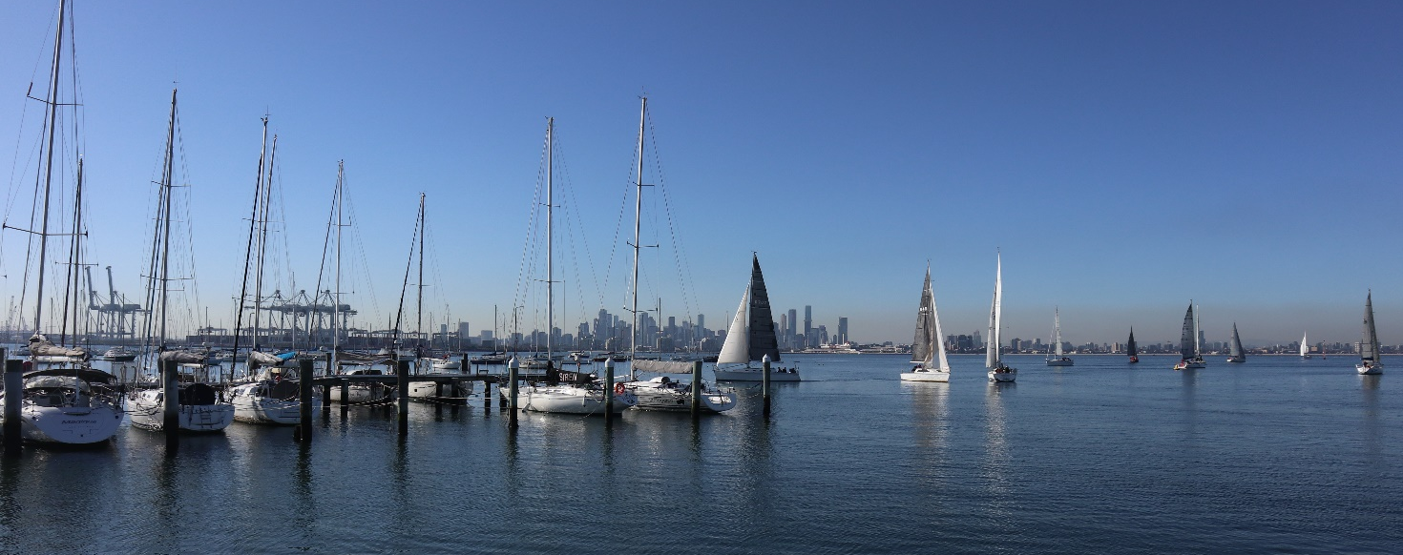
Figure 1 – View of sailing boats and Melbourne CBD from Williamstown

Site Context
The Williamstown Local Port Area is located close to the town centre of Williamstown, approximately 13km southwest of the Melbourne CBD within Hobsons Bay City Council.
The area is physically and functionally central to the Williamstown Maritime Precinct. It is confined to the on-water area managed by Parks Victoria, between and including Ferguson Street Pier and Boyd Street Pier.
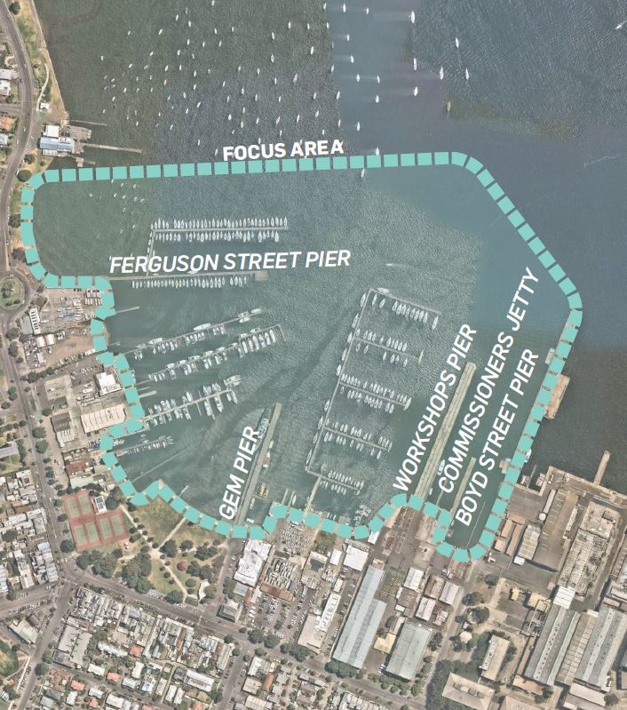

Figure 2 – Site context plan and project focus area

Stakeholder engagement
A Project Reference Group comprising representatives from Parks Victoria, Department of Transport, Hobsons Bay City Council and Bunurong Land Council Aboriginal Corporation have advised on the project.
Preliminary consultation was held with Seaworks and Victoria Police to understand their operational requirements and needs. Input from key stakeholders (Port of Williamstown Action Group, tenants, key users and interest groups) was sought through an online focus group. A summary of the key findings from this focus group was published on a Parks Victoria project webpage when the Draft Plan was released for community consultation in late August/September 2023.
Broader community consultation on the Draft Plan was held for 4 weeks (31 August – 30 September 2023). Parks Victoria launched the plan and survey on Engage Vic, attended a community pop-up event, and created social media posts. A summary of consultation findings can be found in the Community Engagement Report 2023 on Parks Victoria’s website.
Consultation on the proposed modification of a 5-knot zone was also held at the same time as the Draft Plan.
The Bunurong Land Council Aboriginal Corporation (BLCAC) provided input into the draft plan. They were unable to continue in the finalisation of the plan however Parks Victoria will continue to engage BLCAC in further projects related to this local port area as captured in the strategic directions of this plan.
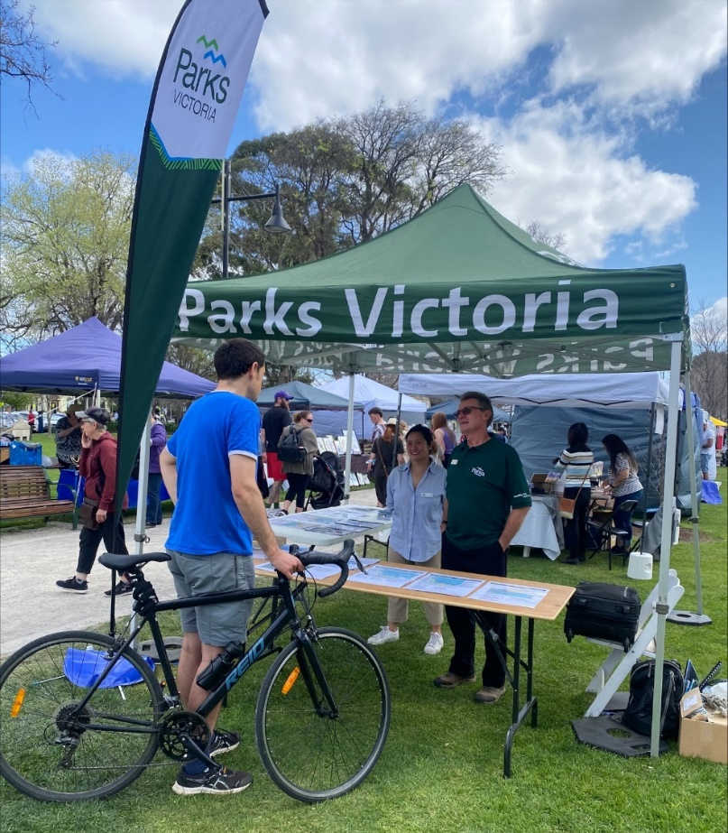
Figure 3 – Parks Victoria attended a community pop-up event to consult on the draft plan and proposed 5-knot rule change

Strategic context

The Williamstown Maritime Precinct Framework and relevance to the Local Port Area Plan
The Williamstown Maritime Precinct Framework was prepared in December 2021 and provides a framework and vision for the precinct to support future land use and infrastructure changes. The Local Port Area Plan continues to build upon this vision, with consideration for and response to the key themes identified in that framework.

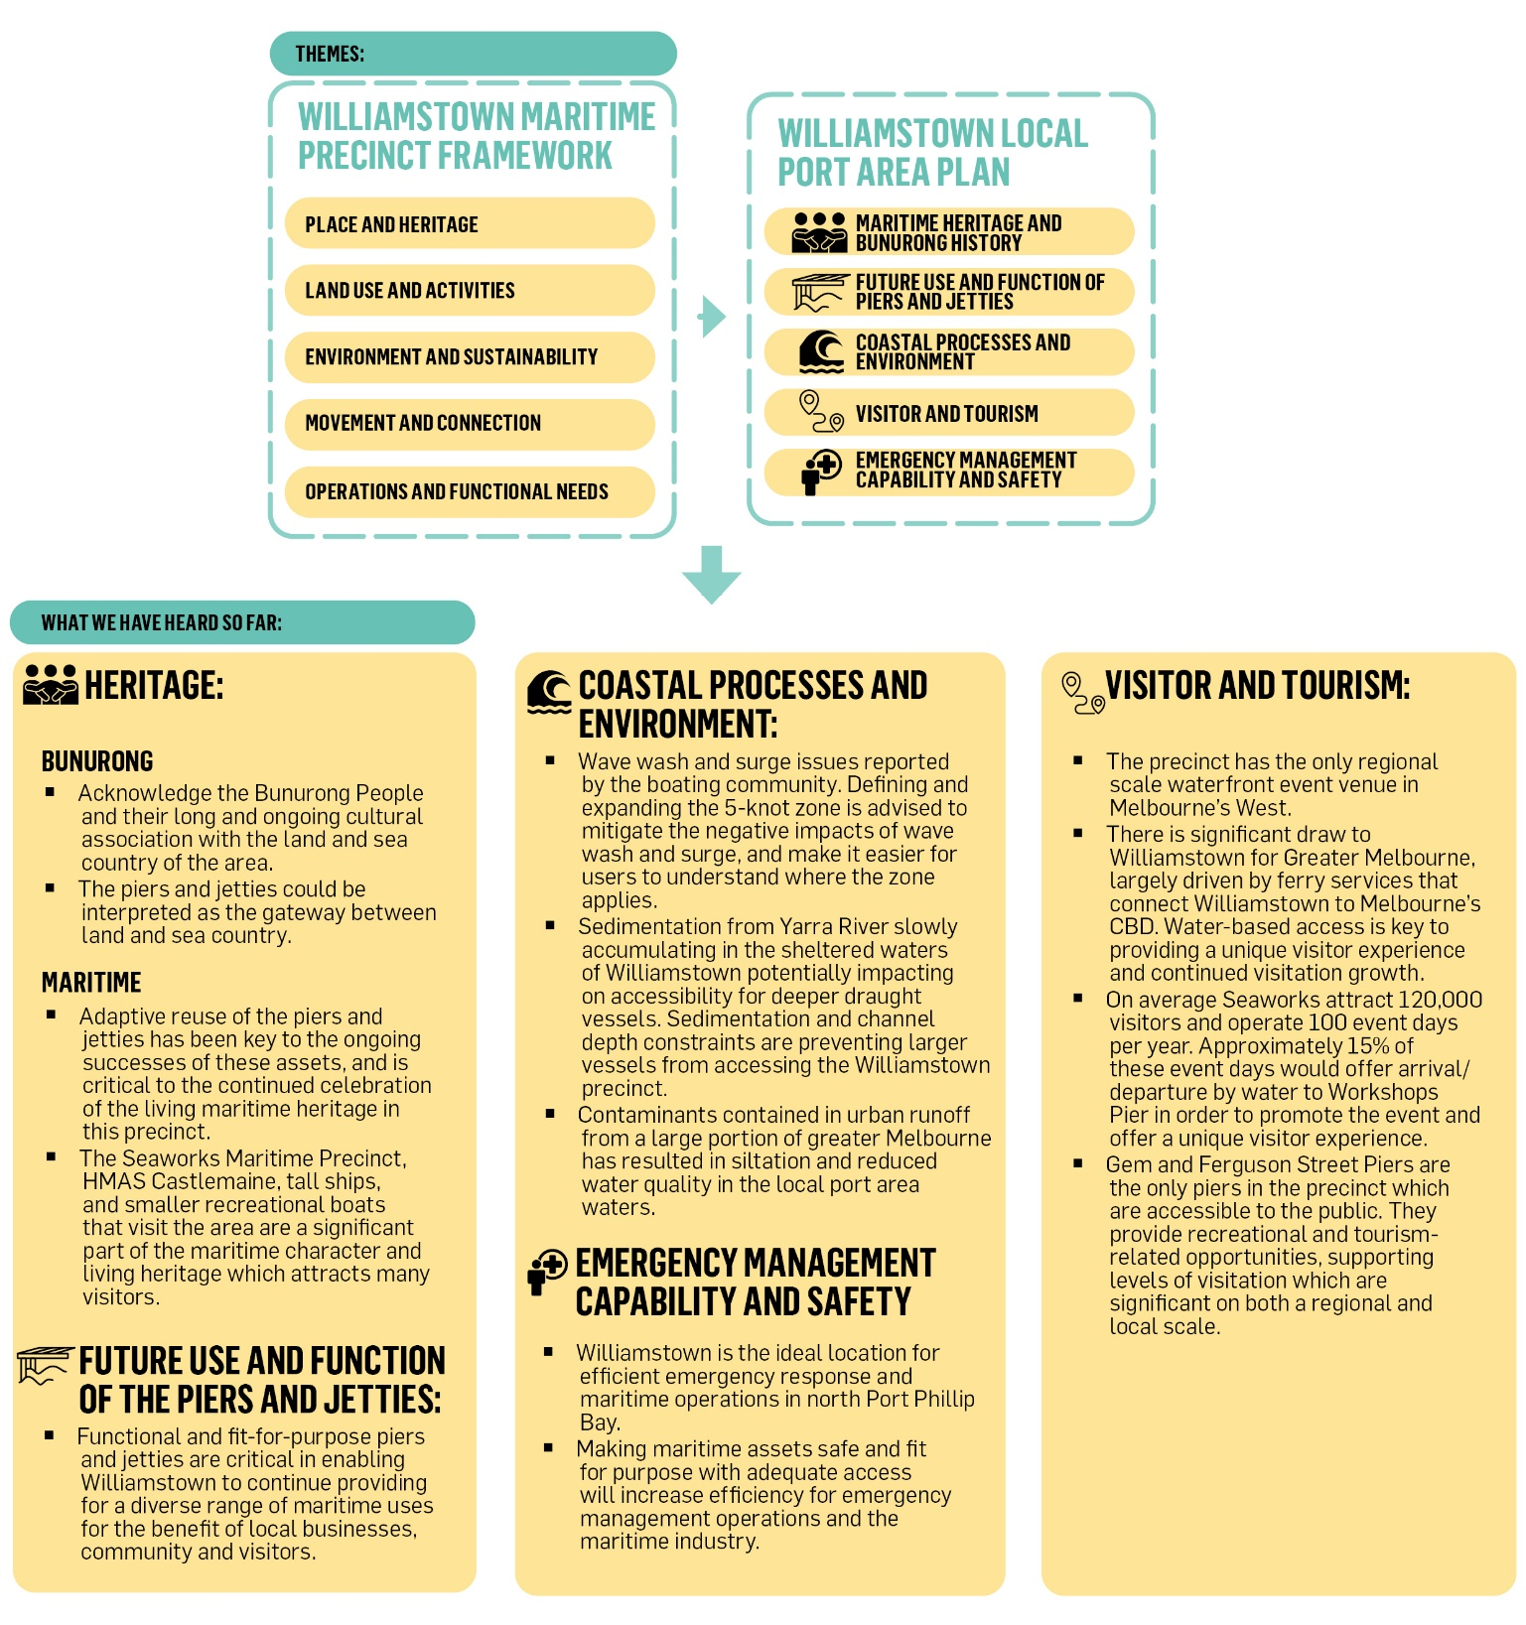
Figure 4 – Response to key themes

Proposing a thriving future for the Williamstown local port area
Williamstown Maritime Precinct Framework Vision:
“The iconic Williamstown maritime precinct will be a cultural, premier maritime and boating destination, centred on the working port. The precinct will preserve and enhance the economic and social values of Williamstown, offering an interactive experience for visitors and the community to engage and learn about the area’s living maritime and cultural heritage, in a safe, connected and resilient environment.”

Figure 5 – Proposed future use and function of the piers and jetties

Improving the function of the local port area
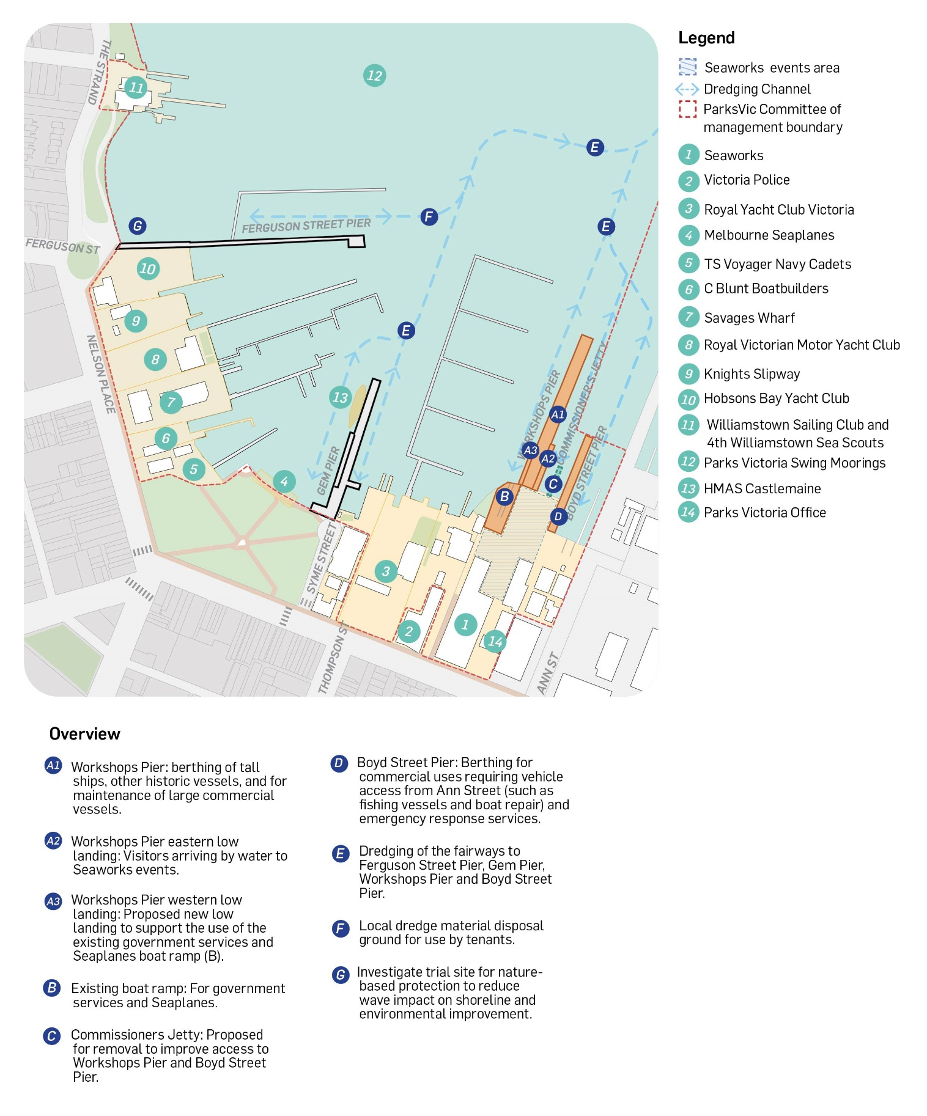
Figure 6 – Proposed key actions to improve the function of the Williamstown local port area

Proposing a future for the piers and jetties
Seaworks manages the piers and jetties at the Seaworks site - Boyd Street Pier, Workshops Pier and Commissioners Jetty. On average, Seaworks delivers 100 event days per year. These events make a significant contribution to the activation of the Williamstown LPA. During these events, access to the on-water infrastructure is limited. However, the proposed uses of these assets will balance needs of Seaworks with operational and community needs.

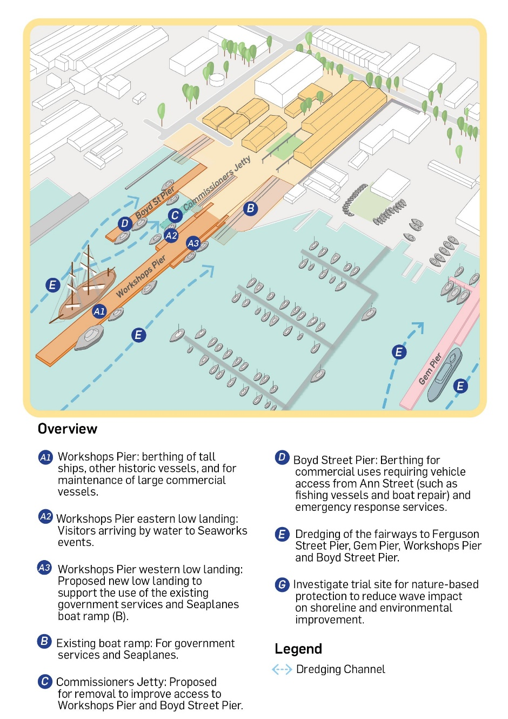
Workshops Pier
Workshops Pier will be retained in largely its current form. It will remain a key facility that enables Seaworks to develop and become the home of dynamic and living maritime heritage events. It will enable berthing of Tall Ships and other historic vessels; provide berthing for maintenance of larger commercial vessels; and as a commercial passenger vessel destination. The eastern low landing will provide for visitors arriving by water to events at Seaworks.
A proposed new low landing to the west will support the use of the existing government services boat ramp, noting that the Seaplanes also have access to this ramp. The boat ramp requires maintenance and improvements to meet operational needs.

Commissioners Jetty
Commissioners Jetty has no current or future functional requirements in the operation of the Local Port Area. It is proposed to remove Commissioners Jetty to improve access to Workshops Pier and Boyd Street Pier, ensuring an improved functional space to meet future maritime commercial and tourism needs. Commissioners Jetty was assessed as of low heritage significance in a 2015 Conservation Management Plan. Parks Victoria will engage with Heritage Victoria regarding this proposal.

Boyd Street Pier
Boyd Street Pier will provide berthing for commercial uses (such as fishing vessels and boat repair), and emergency response services. This will consolidate uses which are somewhat reliant on vehicle access to be closer to Ann Street and opens commercial berthing opportunities at Gem Pier.
Figure 7 – Illustration of the proposed future for the Seaworks piers and jetties

Boyd Street Pier is within the area listed on the Victoria Heritage Register (VHR H1790) and is of historical significance at the State level. Proposed future works to this pier will require a permit from Heritage Victoria, and preparation of a Heritage Impact Statement.

Gem Pier
Gem Pier will be maintained as the key tourism and maritime gateway destination for the Williamstown area where locals and visitors can participate in everyday maritime activity. It will continue being the home of the HMAS Castlemaine, providing a year-round floating museum and maritime heritage display. It will be the point of arrival for passenger ferry services, and tourism operators which require infrastructure to drop off/pick up of passengers from the low landing.
Figure 8 – Gem Pier

Ferguson Street Pier
Ferguson Street Pier will continue to be maintained to facilitate recreational uses (such as pier-based fishing) and public overnight berthing (on the northern side of the pier). It will continue supporting access to Hobsons Bay Yacht Club marina, and member vessel berthing.
Figure 9 – Ferguson Street Pier

Strategic directions (on-water functions and placemaking)
Although this plan focuses on the future of the piers and jetties, there are important considerations and actions required to ensure Williamstown remains a safe and meaningful local port area, securing its future as a premier cultural and maritime precinct.

Bunurong aspirations for Sea Country
Parks Victoria engaged with the Bunurong Land Council Aboriginal Corporation (BLCAC) to ensure their aspirations for Sea Country are reflected in this plan. BLCAC were developing a Sea Country Framework at the time when this plan was developed. Sea Country is an important part of the Bunurong People’s culture and history.
A key action that BLCAC wish to be reflected in this plan is to ensure they are engaged in the future planning of the piers and jetties, and where possible, for their stories and cultural values to be interpreted in the design or experience of the water. These values could be captured in future planning through precinct-wide Cultural Values of Assessment of the Land and Sea Country of Williamstown.
Key action: Continue engagement with the Bunurong Land Council Aboriginal Corporation for the future planning of the piers and jetties.

Maritime and European heritage
A heritage background report has been developed with this plan. It captures the change of form and use of the piers and jetties and demonstrates how adaptive re-use of the assets has been integral to its existence to date. This plan aims to ensure the piers and jetties are fit for purpose and are able to adapt to future commercial and recreational demands and needs, ensuring their ongoing success.
The wealth of history captured in this heritage report will inform a future maritime heritage interpretation strategy for the site more broadly.
Ongoing consultation with Heritage Victoria will also be required to ensure further works carried out on the piers and jetties are in accordance with statutory requirements of the Heritage Act.
Key action: Partner with key agencies to interpret the history and heritage of the broader precinct.

Foreshore connectivity
Although the land side of the foreshore is outside of the project scope for the Williamstown LPAP, the Williamstown Foreshore Strategic Plan (2010) proposes connectivity of the land along the foreshore which is managed by the tenants. The LPAP acknowledges the importance of providing continuous foreshore access to the piers and jetties where possible by integrating the work completed in that strategic plan.
Key action: Parks Victoria will continue to work with the foreshore tenants to achieve the vision of the Foreshore Strategic Plan to improve accessibility along the water’s edge.

Dredging and fairways
The Yarra River is a key source of sediment to Port Phillip due to Williamstown being largely protected from wind and waves. Sediment coming from the Yarra River travels south along the study area shores and settles on the seabed. This sedimentation is a key concern for the area between Ferguson Street Pier and Ann Street Pier where sedimentation has reportedly decreased the available water depth impacting on boat access in the various marinas and businesses.
A Williamstown dredging study was completed in 2017 in consultation with the key on-water users of the area. The proposal is to create a local dredge material disposal area that will enable small volume ad hoc maintenance dredging campaigns by tenants to be delivered in a cost-effective manner. The maintenance dredging program will be managed under an Environmental Management and Monitoring Plan specific for the site. The Environmental Management and Monitoring Plan will ensure that environmental risks are actively managed and mitigated, and that the dredging is carried out with minimal environmental impact.
Dredging of the fairways to Ferguson Street Pier, Gem Pier, Workshops Pier and Boyd Street Pier will provide safer navigable waters to Williamstown, providing a benefit to commercial and recreational users, and related businesses.
Key action: Undertake the necessary statutory approval processes to progress dredging needs when future funding is available.

Environmental resilience
Located at the mouth of the Yarra River, the environmental values in the Williamstown LPA are impacted by contaminants contained in urban runoff from a large portion of greater Melbourne, resulting in siltation and reduced water quality. There are also many marine pest species in this part of Port Phillip such as the Northern Pacific Seastar (Asterias amurensis) and Japanese Kelp (Undaria pinnatifida).
The LPAP builds on key environmental objectives from the Williamstown Maritime Precinct Framework, such as contributing to “an adaptive and resilient precinct” and to “support opportunities for locals and visitors to get involved in management initiatives and programs for the marine environment”. Two strategic sites in the precinct have been identified by key stakeholders. These are Greenwich Bay and abutting the northern shoreward side of Ferguson Street Pier. These locations have the potential to be trial sites for nature-based protection, such as artificial reefs similar to those that have been deployed in other locations within Port Phillip. The aim is to reduce wave impact on the shoreline, provide substrate for marine organisms to attach to and improve the marine environment and water quality. This is a great opportunity for the community to be involved with through partnerships with environmental organisations, universities and philanthropic partners.
Key action: Support any community project that investigates the deployment of artificial reefs in consultation with land managers and key stakeholders to improve the marine environment and water quality within the Williamstown local port area.

Wave climate
The purpose of the Williamstown Wave, Wash and Surge Study (WWSS) (2022) was to identify the cause of the ‘wave, wash and surge’ issues that have been anecdotally reported and recorded in the Williamstown maritime area by the boating community and to prepare potential options for future mitigation.
Implementation of the mitigation options has been considered and supported by key government Departments and Agencies.
Five key viable mitigation options were identified in the Williamstown WWSS:
1. Creation or modification of a 5-knot zone, i.e. Extend the 5-knot speed limit from the foreshore to the channel boundary of the Williamstown channel
2. Education and enforcement of speed control/limit of recreational boats
3. Education and enforcement of speed control/limit of fast ferries
4. Wave attenuation at the local marina scale
5. Education and enforcement of speed control/limit of large commercial vessels.
Key action: Parks Victoria will continue to progress the proposed 5 knot rule change.

Next Steps and Implementation
Following release of the Williamstown LPAP, Parks Victoria and the Department of Transport and Planning will develop future business cases to realise the actions of this plan. The implementation of the key proposals and actions will not occur immediately, but will be staged over many years.
Priorities from this plan are the re-opening of Workshops Pier, seeking approval to change the 5 knot rule, and to seek funding to commence the technical studies required to seek approval for dredging.

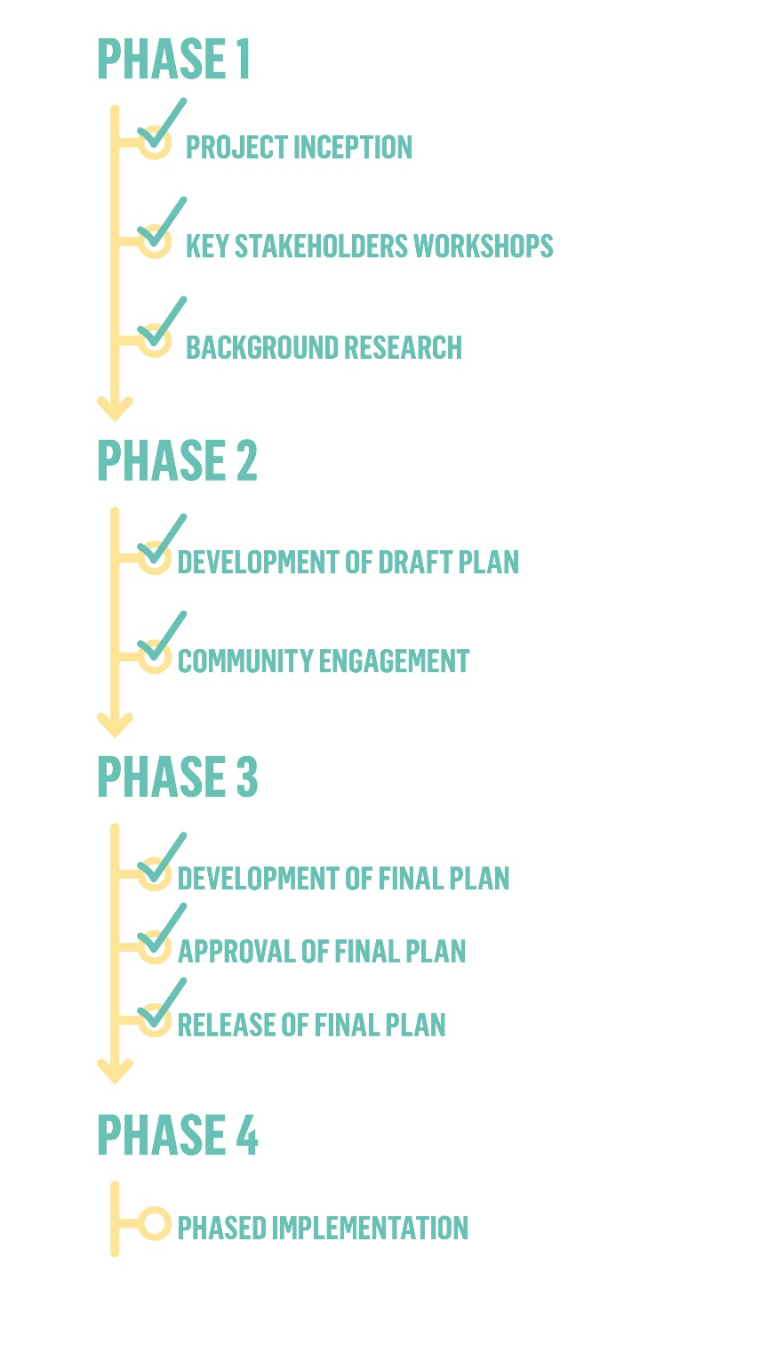
Figure 10 – Project timeline

References
Ferguson Street Pier:
AWM3576 Ferguson St Pier Condition Inspection Report-Rev A KD.pdf, AW Maritime, January 2022
J759_HBYC_Ferguson St Pier Pile Survey_ Report_v1_20210719.pdf, Professional Diving Services, July 2021
31-11268-W0001-R1.PDF, Site and Locality Plan, Parks Victoria, October 2023
31-11268-W0002-R1.PDF, Pre-construction Survey Plan, Parks Victoria, October 2023
Ferguson Street Pier - Set aside.pdf, Parks Victoria, July 2020
Gem Pier:
2018060198_Southern Divers_ GemPierInspection_ParksVic_v2.pdf, Southern Divers, July 2018
V181496_REP001v03_Gem Pier Condition Inspection Report - Final.pdf, Cardno, May 2019
3580 Gem Pier Fenders.pdf, As Constructed, AW Maritime, Unknown
Gem Pier Detailed Drawings, As Constructed, GHD, April 2003
Gem Pier - Set aside.pdf, Parks Victoria, July 2020
Gem Pier Berthing Occupants List, Parks Victoria, Unknown
Seaworks Piers and Jetties:
AWM3576 Boyd St Pier Condition Inspection Report-Rev B.pdf, AW Maritime, February 2022
AWM3576 Commissioner’s Jetty Condition Inspection Report-Rev B.pdf, AW Maritime, February 2022
AWM3576 Workshops Pier Condition Inspection Report-Rev C.pdf, AW Maritime, May 2022
Boyd Street Pier:
AWM3576 Boyd St Pier Condition Inspection Report-Rev B, AW Maritime, February 2022
Consultation Findings:
Parks Victoria VSM 2022 Gem Pier Dashboard.pdf, Parks Victoria, March 2023
Williamstown Local Port Area Plan Project, Stakeholder focus groups key findings, Parks Victoria, 2022
Williamstown Local Port Area Plan Stakeholder Consultation Summary Report, Parks Victoria, 2023
Spatial:
Bathymetry Survey, NA, NA
GIS Data Records, Parks Victoria, March 2022
Williamstown Fairway Report, GHD, 2007
Wave, wash and surge study, BMT, 2022
Wave, wash and surge study, AW Maritime, 2017
Strategic and Management Plans:
Williamstown Vessel Management Plan, Geo Dimensions, 2008
Local Port Area Planning Guideline, Draft, Department of Transport, October 2022
Coastal and Marine Management Plan, Hobsons Bay City Council, 2021
Local Ports Sustainable Framework, Department of Transport, 2022
Victorian Marine and Coastal Policy, DELWP, March 2020
Victorian Marine and Coastal Strategy, DELWP, March 2020
Seaworks Strategic Development Plan, Final Report, Aurecon, May 2009
Williamstown Foreshore Strategic Plan, Parks Victoria, 2010
Williamstown Local Port Area, Heritage significance review and assessment, GML Heritage, December 2022
Williamstown Maritime Precinct Framework, Final Report, GHD, December 2021
Victorian Marine Spatial Planning, BMT, 2022
Coastal and Marine Management Plan, Alluvium, 2021
Local Port Area Planning Guideline, Geo Dimensions, 2021
HMAS Castlemaine Relocation report, Cardno, 2021
Tall Ships Victoria Data:
International Tall Ships Festival 2013, Melbourne Program (DRAFT), Tall Ships Victoria, 2013
Tall ships 2013 - pier availability.docx, Tall Ships Victoria, September 2020
TSV Port Facilities to Service visiting Tall Ships. Xlxs, Tall Ships Victoria, Unknown
TSV Vessel Data.xls, Tall Ships Victoria, Unknown
Parks Victoria
Level 10, 535 Bourke St, Melbourne VIC 3000
parks.vic.gov.au
13 1963

