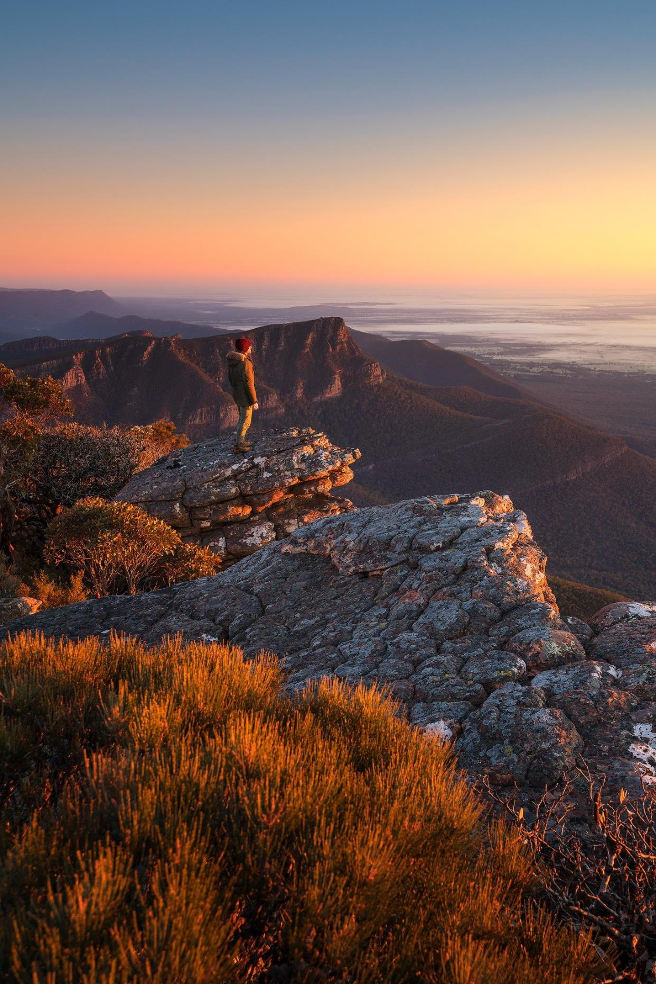
SUSTAINABLE FILMING & PHOTOGRAPHY GUIDE

December 2020

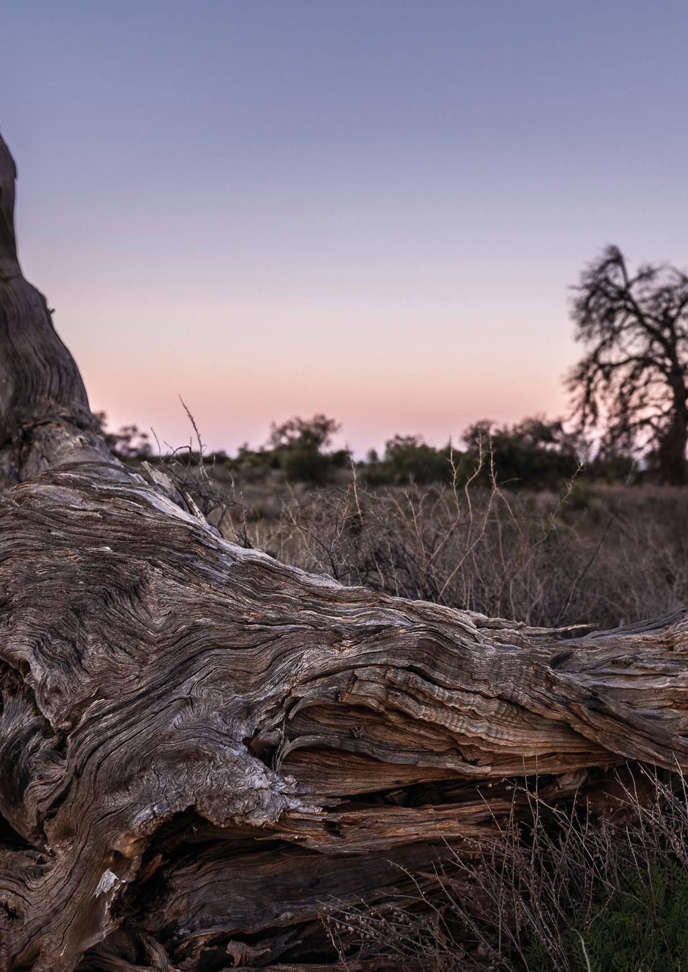
Acknowledgement of Country
Victoria’s network of parks and reserves form the core of Aboriginal cultural landscapes, which have been modified over many thousands of years of occupation. They are reflections of how Aboriginal people engaged with their world and experienced their surroundings and are the product of thousands of generations of economic activity, material culture and settlement patterns. The landscapes we see today are influenced by the skills, knowledge and activities of Aboriginal land managers. Parks Victoria acknowledges the Traditional Owners of these cultural landscapes, recognising their continuing connection to Victoria’s parks and reserves and their ongoing role in caring for Country.

This publication may be of assistance to you but Parks Victoria and its employees do not guarantee that the publication is without flaw of any kind or is wholly appropriate for your particular purposes and therefore disclaims all liability for any error, loss or other consequence which may arise from you relying on any information in this publication.
Authorised and published by Parks Victoria
Level 10, 535 Bourke St, Melbourne VIC 3000
Copyright © Parks Victoria 2020

Cover image: Mount William, Grampians National Park
Inside cover image: Murray-Sunset National Park

Contents
1.0 Introduction 4
2.0 Six steps to transition to greener production practices 5
2.1 Park protection 5
2.2 Catering 5
2.3 Transport 5
2.4 Props & equipment 6
2.5 Waste management, recycling & composting 6
2.6 Power 6
3.0 The waste hierarchy 6
4.0 Sustainable filming 7

1.0 Introduction
For decades the film, television and photography industry have showcased Victoria’s diverse natural environments. Parks Victoria manages over 18% of Victoria, including iconic locations such as the Grampians, Twelve Apostles, the Victorian Alps and Wilsons Promontory.
The environmental impact of the film industry is significant. The average 60-minute television show produces roughly 9.2 tonnes of carbon dioxide. Other factors, such as catering, plastics, waste and transport are key contributors to the impact your production can have on Parks Victoria’s estate and the wider environment.
We all have a responsibility to protect Victoria’s natural and cultural assets. Victoria’s natural assets are important collateral for your film, and to ensure filming like yours continues, you need to help us protect our natural landscapes.
This guide includes helpful tools to adopt throughout your production to transition onto a greener and more sustainable trajectory. This is how others are caring for the land on which they’re filming. How will you play your part?

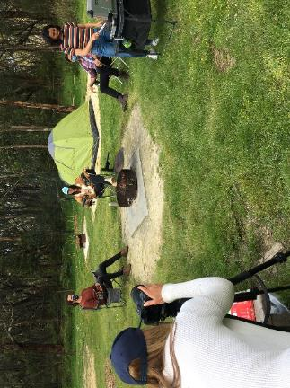
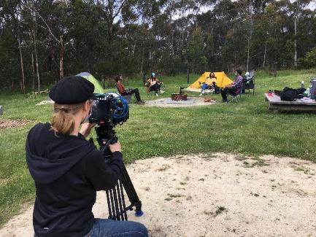

Above: Photo & video shoot; Great Otway National Park

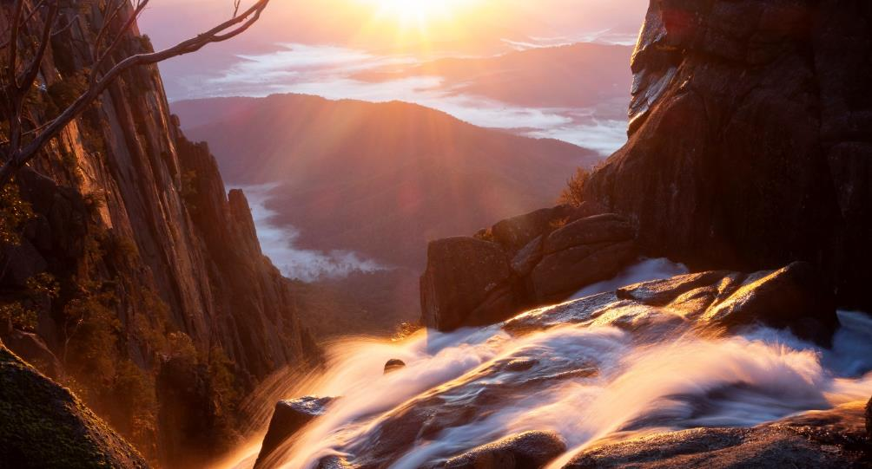

Above: Crystal Brook Falls, Mount Buffalo National Park

2.0 Six steps to transition to greener production practices

Park protection
As a conservation agency, Parks Victoria is committed to protecting Victoria’s biodiverse environments. We ask you to please consider the value and importance of the land on which you are developing your production.
  - Undertake a recce prior so any questions you have regarding the site can be addressed by rangers prior to the shoot day. You will be provided with contact details for a local park ranger, when you receive your permit. We can arrange contact with the relevant local staff.
  - All permit applications will be assessed by Parks Victoria to ensure compliance with the Aboriginal Heritage Act 2006. To assist with this assessment, an accurate and detailed description of your proposal must be included in the application, particularly if ground disturbance of any type is being proposed. All permits issued will be subject to conditions. Meeting these conditions will be the responsibility of the Permit Holder.
  - Many locations on PV estate will have particular significance for Aboriginal people which are not necessarily protected by state heritage legislation. PV suggests early consultation about your project with Traditional Owners to ensure it is compatible with their cultural norms and values. Appropriate engagement will also ensure intellectual property is not infringed upon. Aboriginal Victoria can provide advice on the appropriate custodians with whom to consult.
  - Ensure you are aware of any sensitive plant and animal species within your filming area and outline any mitigation strategies to avoid harm. Please contact events@parks.vic.gov.au for further information.
  - Don’t attach anything to trees, break branches or go over barriers. If your location is off designated tracks, identify this within your permit application.
  - Minimise the footprint for filming activity as much as possible and locate caravans and equipment on previously disturbed areas if possible.
  - Cast and crew are not to interfere or disturb any wildlife. Be mindful of noise and light. Limit filming at dawn, at night and dusk as this is the time that nocturnal animals are active. If needed, used filtered light or keep any other light to a minimum
  - Carbon offsetting is tool that can be used to mitigate the environmental impact of your production. Keep track of distances travelled, and petrol, electricity and water usage.
o Consider a donation to a friends of the park group, to help with environmental activities or make an arrangement to fund some equipment/plants.
  - Carbon Fund and other carbon offsetting platforms can inform you on what data needs to be tracked and gives estimated costs.

Catering
  - When engaging with caterers prior to your shoot, ask them to consider the number of cast and crew and match quantities to reduce food wastage.
  - Ask crew members to bring reusable crockery/container and cutlery to work and provide dishwashing facilities for them to rinse their items before taking home. Please note greywater needs to be captured and disposed of to a sewer system.
  - Prioritise catering that uses fair trade, local, seasonal, carbon neutral and/or any other sustainable food options. For a list of social catering enterprises that service the Melbourne area, see here.
  - Consider having vegan or vegetarian days on set to reduce purchasing of meat.
  - Donate any leftover or unused foods to cast and crew to take home or charity organisations after your shoot

Transport
  - Consider carpooling to your set location to avoid unnecessary transit and emissions.
  - If your set is in a remote location, decide on a central meeting point where people can park, then carpool or arrange a shuttle bus to transport crew to the location. This will also decrease parking issue and potential damage or impact on the park and its visitors.
  - Where face to face meetings aren’t essential, use digital platforms to meet with colleagues. This will cut back on emissions from unnecessary travel and saves on travels costs.
  - When possible, consider opting for hybrid or electric vehicles/trucks for your shoot. Or, limit the amount of trucks used on location.

Props & equipment
  - Before procuring any new equipment and/or props, consider purchasing second-hand goods or prop and wardrobe rental.
  - No single use plastics such as balloons or glitter. Promote alternatives such as bubbles, recycled lanterns or bunting.
  - If your production is likely to have leftover equipment, tools, material, wardrobe etc. that cannot be used for future projects, consider donating it to charities or social enterprises.
  - Use digital alternatives to printed call sheets, scripts, contracts etc. Where digital alternatives aren’t feasible (i.e. night shoots), ensure all paperwork is made from recyclable paper and can be recycled at the end of each day.

Waste management, recycling & composting
  - Ensure there are enough bins and empty or replace bins when they are full. Use colour and standard signage to make sure the recycling and composting bins are distinguishable. Signage templates are available on the Sustainability Victoria website.
  - Compost food waste in a separate bin and drop it off to a local compost depot after your production or engage a waste management company to deliver and collect compost and recycling bins.
  - Identify types of waste to be generated throughout the production, adequately planning for their management by developing a waste management plan (the different waste streams available and third parties to collect compost, recycling etc.)
  - For long term shoots, consider renting a composting toilet service to reduce water and energy wastage.
  - Ensure no litter is present after each day of shooting

Power
  - Turn off lights, power boards and computers and unplug equipment at the end of each day.
  - Although there are currently limited sustainable alternatives in Victoria, if possible, use renewable power sources instead of fuel generators
  - Use energy efficient electronics and LED lights both on set and in the production office
  - Open windows or use fans rather than using an air conditioner

3.0 The waste hierarchy
Most Preferable

Least Preferable

We welcome your feedback. If you would like to suggest improvements to this guide, or share with us case-studies of your sustainability initiatives, please provide feedback to us at events@parks.vic.gov.au

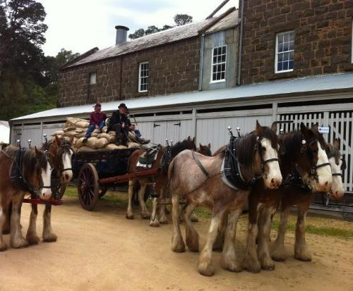
Above: Andersons Mill 150 Year Celebration

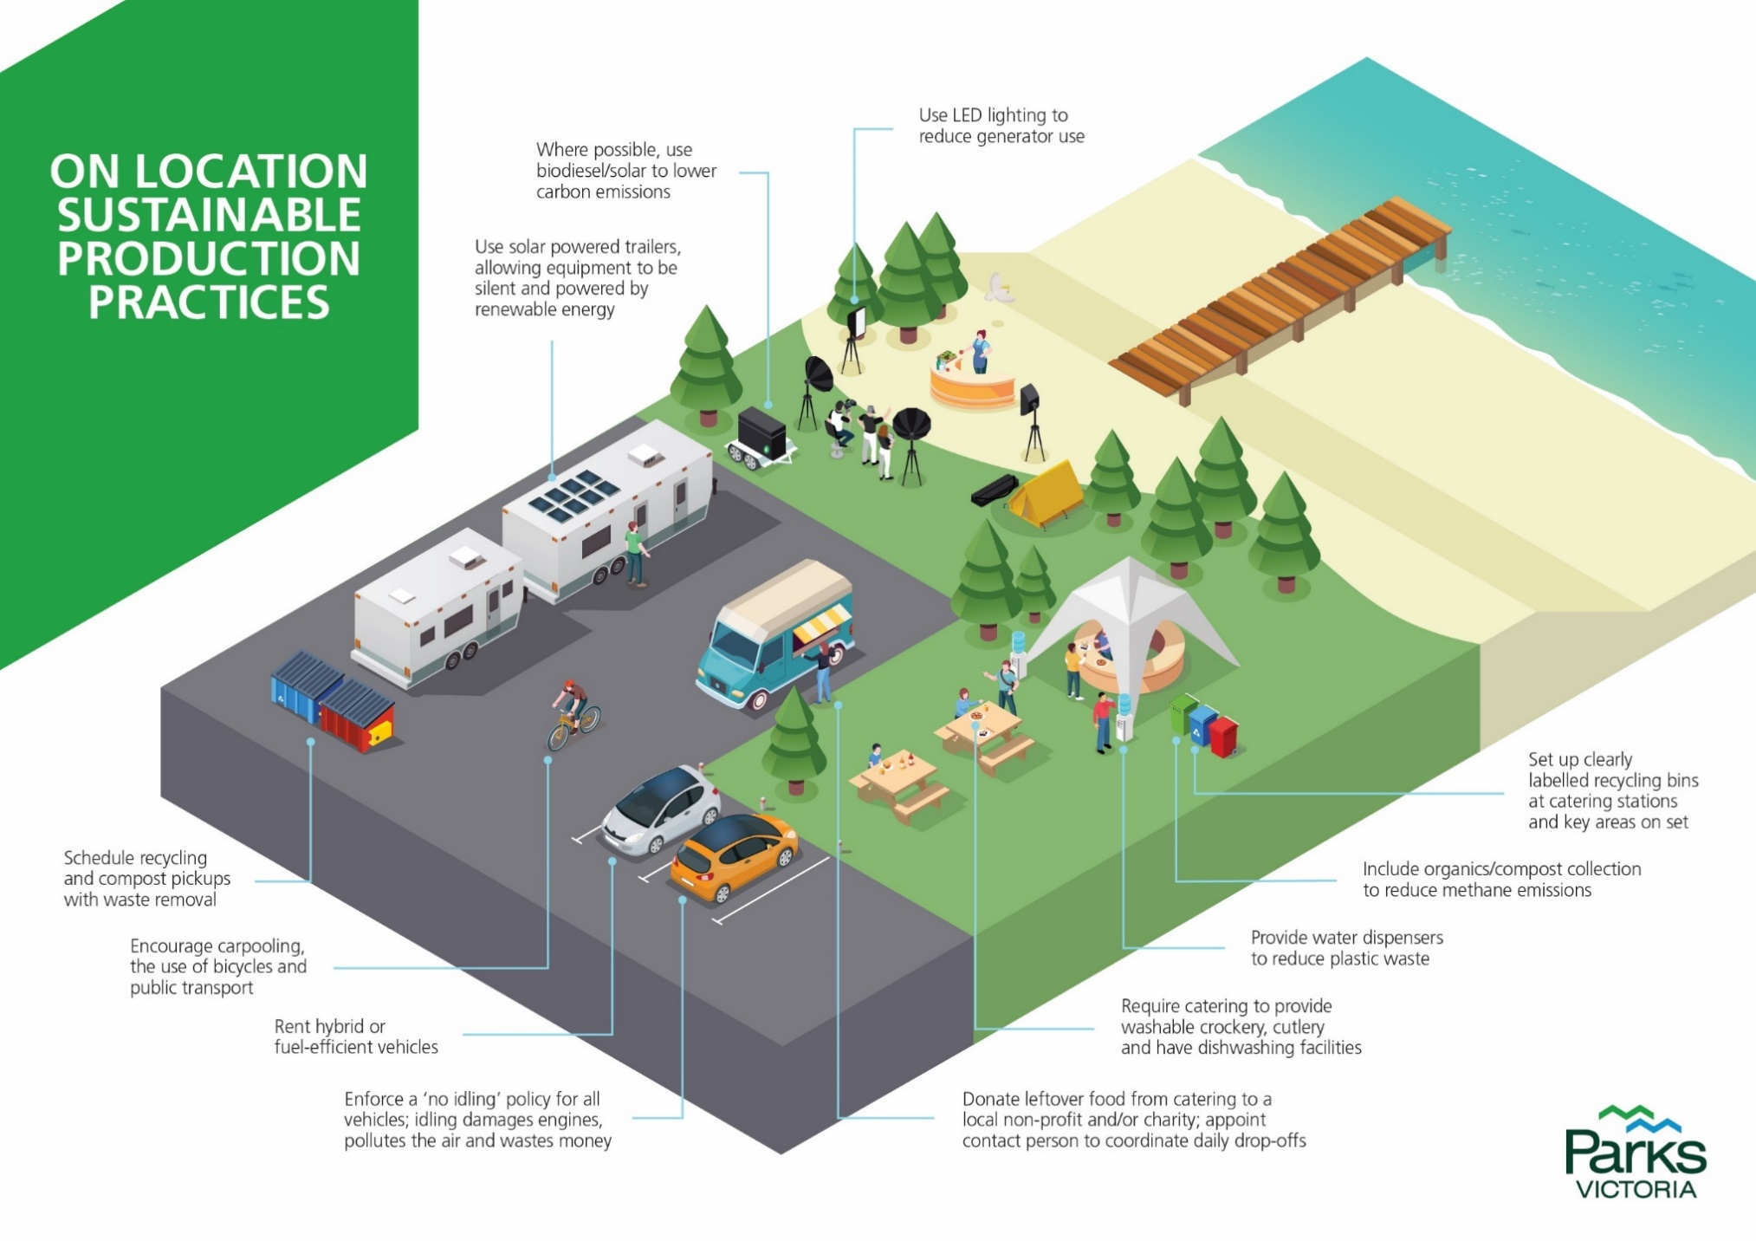
4.0 Sustainable filming
Parks Victoria
Level 10, 535 Bourke St, Melbourne VIC 3000
parks.vic.gov.au
13 1963

wearealbert.org/2019-2020-annual-report
greenproductionguide.com

