EOI Application Form

Brambuk Café Service
Grampians (Gariwerd) National Park

Invitation for EOI Application

About the site
The Brambuk Aboriginal Cultural Centre was built in 1989 to acknowledge, protect and share the cultures of the Jadawadjali and Djab Wurrung Peoples. It was collaboratively designed with the Traditional Owners of Gariwerd to celebrate connection to Country.

In 2006, the Park Visitor Information building was added, which now houses the National Park information service, a café space and gift shop.

Parks Victoria has temporarily taken over the management of Brambuk, in association with Gariwerd Traditional Owner corporations, Barengi Gadjin Land Council, Gunditj Mirring Traditional Owners Aboriginal Corporation and Eastern Maar Aboriginal Corporation.

Brambuk’s service offer
In great news for Brambuk and the region, the Victorian Government Budget 2020–21 has allocated $5.8 million to upgrade buildings, refresh activity spaces, and develop new long term environmental and cultural programs at the precinct.

Whilst the Cultural Centre is currently closed for upgrade works, the precinct’s Park Visitor Information building is open. Current services include retail/souvenirs, national park information, map sales/activity brochures, campground bookings, permits and minor interpretive displays, as well as scheduled school holiday activities.

Since re-opening in late 2020 following the lifting of COVID-19 restrictions, Brambuk has seen consistent visitation attracting between 100 – 400 visitors a day from December 2020 through to April 2021. Increasing visitation is expected at Brambuk over the next 24 months as new cultural services and activities become available at the site, in addition to the opening of the Grampians Peaks Trail in 2021.

The Opportunity
Expressions of interest are open for a suitably qualified operator to run an over the counter café service, within the Park Visitor Information building at Brambuk. The opportunity will ideally attract a local operator capable of expanding existing operations to cater for a new market.

Key items include:
- Minimal fit-out required. The existing café, kitchen and service area of the Park Visitor Information building is available for use by the successful operator.
- Additional cafe equipment (Point of Sale, coffee machine, tables/chairs, food display, approved signage, etc.) is to be provided and managed by the operator.
- The successful operator will be granted access to the Permit Area (in accordance with the standard clauses within the Trade Permit), for a period up until 30 June 2023.

Trade Permit and Fees
A standard National Parks Act (1975) Trade Permit, and a Trade Permit fee will apply.

EOI Objectives
To appoint an operator to deliver café operations that:
- Ensures the consistent sale of good quality, locally-sourced food and beverage to complement the Brambuk visitor experience;
- Is capable of catering for events and functions held at Brambuk;
- Supports Brambuk’s cultural experience, showcasing Indigenous bush tucker and ingredients where possible/appropriate; and,
- Can provide tangible benefits to Gariwerd Traditional Owner communities, such as supporting Traditional Owner businesses and suppliers, and/or direct employment opportunities.

Applications
All applications are to be submitted via the Parks Victoria Expression of Interest (EOI) email address at EOI@parks.vic.gov.au

Applications with email Subject: ‘Application – Brambuk Café Service’ are due by midnight AEST on Sunday 11 July 2021, together with the signed Conflict of Interest Declaration.

Assessment
Applications will be assessed by a skills-based assessment panel, against the questions and evaluation criteria in the application form.

Enquiries & Site Visits
All enquiries must be directed in writing to EOI@parks.vic.gov.au. Dates and times for site visits will be scheduled once the availability of all interested parties is known.

Application Form - Brambuk Café Service

Instructions: This is an electronic application form. Simply type your responses into the grey fields which will expand to the content. Once complete, save and email your application (with supporting documentation). Submission details below.

Before completing the application form, make sure you have read the Invitation for EOI Application and supporting documentation.

- Name of Applicant
Business / Trading Name:
Business telephone number Mobile number Email
Note: The agreement is issued in the business / trading name and must match the Certificate of Currency provided to Parks Victoria. An ASIC extract must be attached to evidence the entity. Email address may be used to communicate fire and emergency information
to you in relation to the Park

- Applicant status
Individual | What is your ABN?
Company | What is your ACN?
Incorporated Association | Registration number?
Charitable organisation*
Not-for-profit organisation* | * Must provide evidence of this status with your application

- Business address
Street number and name
Suburb State Postcode

- Postal address
Same as business address OR Street number and name/P.O. Box
Suburb State Postcode

Evaluation Criteria

Proposal Concept 15%

- Outline a brief vision for the site, including your proposed service offer and staffing structure

- Provide a list of café equipment to be brought on site and any additional fit out proposed (with images)
See Appendix A for a site map with the proposed permit area. The Service Provider must not bring any equipment on to the site without the prior written consent of Parks Victoria.

- Proposed minimum hours, days and months of operation (Brambuk’s current hours are 9am – 5pm, 7 days a week)
 | Monday | Tuesday | Wednesday | Thursday | Friday | Saturday | Sunday | Public Holidays
Time open
Time close
Days and times of operations committed (to be included in the Trade Permit terms and conditions). Applicants must be clear if operating hours are to change during different months/seasons.

- Proposed start date
The end date for the Trade Permit is 30 June 2023

Business management and viability 25%

- Outline your business’ and staff experience and credentials in operating a café

- Provide a list of local suppliers or partners in the delivery of your proposed operations

- Provide 12-month revenue and expense (P&L) projections with clear assumptions
An annual Trade Permit fee will apply.

Strategic Alignment 25%

- Highlight any ways that your operations will deliver tangible benefits to Traditional Owner communities, e.g. supporting Traditional Owner owned and/or managed businesses and suppliers, or employment opportunities

- Provide a full menu with pricing, highlighting which of your menu items align with the Victorian Government’s Healthy Choices Guidelines

- Outline your capacity to track sales and visitor data to inform an End of Agreement report
The Trade Permit requires the operator to track sales, expenses and collect visitor data

Visitor Experience 20%

- Highlight any ways your operations will support the cultural visitor experience at Brambuk, such as the inclusion of native bush tucker ingredients and menu items

- Outline your capacity to meet increased demand with visitation peaks and catered events occurring within the Brambuk precinct

Environmental management 15%

- Outline how the business will evidence and promote environmental sustainability e.g. sustainable packaging, recycling and waste disposal, local produce etc
At a minimum, an adequate number of rubbish bins must be provided to service the needs of patrons, and the site must be kept tidy and free from all rubbish that is caused by the provision of café services. All rubbish and waste is the responsibility of the permittee and bins must be provided and maintained.

Mandatory supporting material

Please attach the following material to complete your application:

Evidence of applicant business status
Certificate of Currency (Public and Products Liability insurance) for a minimum of twenty million dollars ($20,000,000). This Certificate must be in the same name as stated in the applicant details;
12-month financial projections
Images to support application

Declaration and Signature

I declare that:
- I have read the Parks Victoria Trade Permit document
- By applying to Parks Victoria, I acknowledge and accept all agreement conditions
- I am authorised as the holder of the position cited below to submit this application on behalf of the applicant
- To the best of my knowledge the contents of this application and all attachments are true and correct

I acknowledge that if lodging this request electronically, Parks Victoria will accept this communication as containing my signature for the purposes of the Electronic Transactions (Victoria) Act 2000.

Signature of Applicant (if lodging electronically, type name here) Date
X
Printed name Position

Conflict of interest declaration

Application for Café Service Brambuk: The National Park and Cultural Centre
All applicants are required to complete the following conflict of interest declaration. Where a relationship exists with any Parks Victoria staff member, please outline the details to be kept on record. Where a conflict of interest detrimental to the assessment process has been identified by Parks Victoria, a person may be asked not to participate in the EOI process.

Section 1: Applicant / prospective tenant

Name:

Position/Title:

Organisation:

Phone Number:

Email:

Address:

Section 2: Conflict of interest
As an applicant in this process I do not have any conflict of interest in this project
(including an actual or a perceived conflict of interest).
OR
- I have identified a perceived or actual conflict of interest with the following persons

The conflict relates to (tick appropriate box/s):

Relationship with PV staff member | Outside work activities (paid/unpaid)
Relationship with external parties | Conflict of duty (e.g. membership of another public sector or private organisation)
Financial interest | Other (please detail):

The conflict is expected to last (tick appropriate box):

0-12 months >12 months Ongoing

To the best of my knowledge and belief, any actual, perceived or potential conflicts between myself, my business and Parks Victoria and/or the Project Manager have been fully disclosed in this declaration form. I acknowledge and agree to comply with any directions from Parks Victoria in respect of any actual, perceived or potential conflict of interest.
Signed:
Name:
Date:

Appendix A – Proposed Permit Area
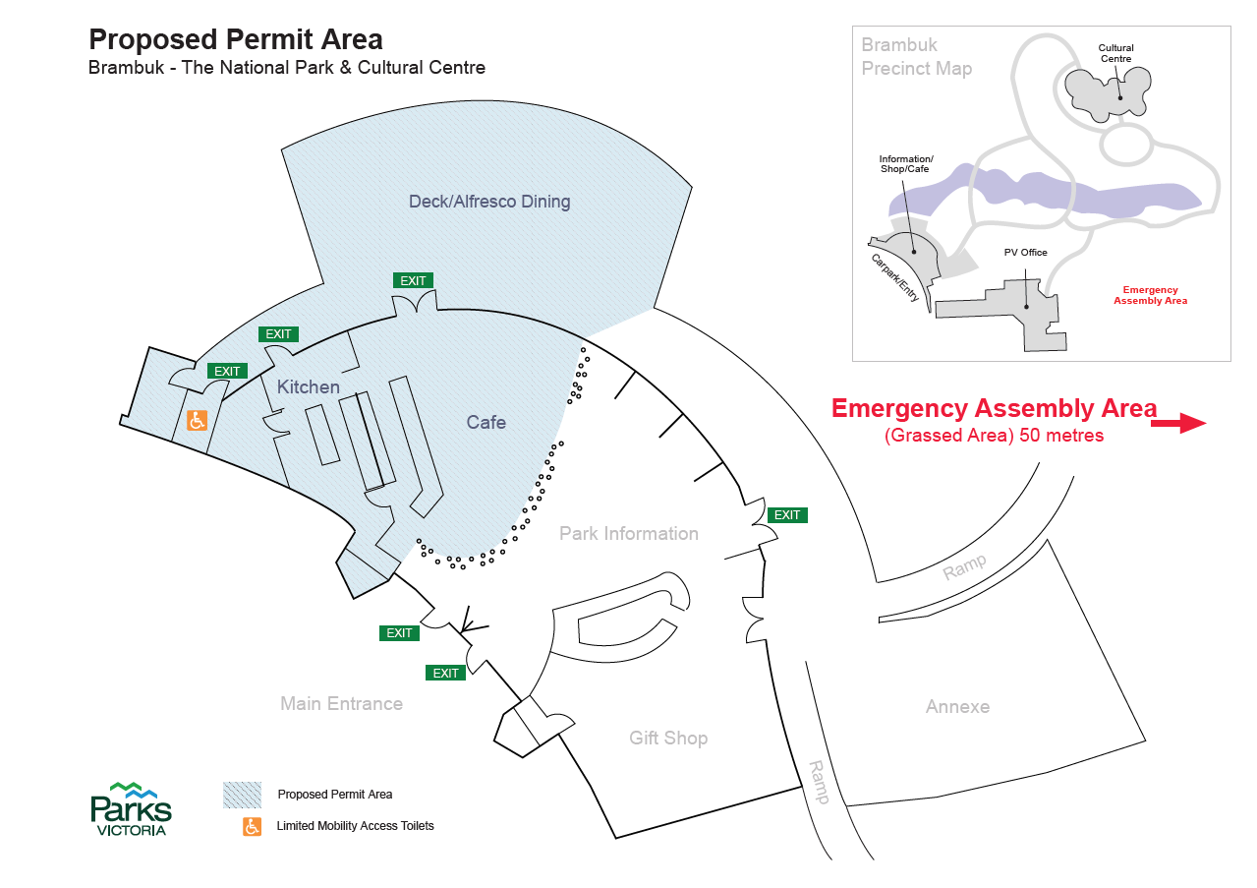

Appendix B – Map Central Grampians

